Students’ Union Activity Committee Kit Order Form 2024-25

Ordering - Please use this form to order any Activity Sport and Leisurewear for Committee, training or playing purposes. Please email the completed form to callumbell@pslteamsports.com and c.c. in the Students’ Union Sports Office on fixtures@abdn.ac.uk.

Payment Following receipt of your order, a pro-forma invoice will be issued from Stevensons to your Activity @AUSA Email address as indicated on the form below. Full payment of this invoice is required prior to the submission of your order into production. By submitting this form, you are taking responsibility on behalf of your Activity for the payment of all products as required below

Delivery – All deliveries will be to the Students’ Union Sports Office, Aberdeen Sports Village, Linksfield Road, Aberdeen. The Sports Office will be in contact once they are in receipt of the delivery. Please note that there is a delivery charge of £6.95 for all orders under £250. Orders over £250 have free delivery.
- XXV standard items will take approx. 3 weeks for delivery following payment,
- Sublimated and new kit will take approx. 5 weeks.
- Canterbury stock will take approx. 8-10 weeks.

Online orders - You can still order online directly from PSL, but delivery from the website will take longer.

Committee Clothing - to keep things as accessible as possible, we have tried to offer more options for you to ensure that everyone has access to an item of committee clothing at a reasonable price. All items are grey in colour and there are 3 design options that you can choose from: -.
- Option A –Students’ Union & University of Aberdeen crests only.
- Option B – as option A with addition of Activity name on the back
- Option C – as Option B with addition of name and committee position on the sleeve

Sizes - all items are available in unisex sizes XS(38”), S(40”), M(42”), L(44”), XL(46”), and 2XL(48”). Sample sizes can be viewed at Students’ Union Sports Office. If you require a different size, please speak to Callum at PSL.

Prices and examples – below will find images of what the hoodies, t-shirts, crew neck and quarter zip sweatshirts look like, along with prices.

Committee Hoodie  Option A - £24.75  Option B - £28.25  Option C - £32 | Committee ¼ zip sweatshirt  Option A - £28.50  Option B - £32.25  Option C - £35.75 | Committee sweatshirt  Option A - £23.25  Option B - £26.25  Option C - £29.25 | Committee tee  Option A - £13.75  Option B - £17.5  Option C - £21
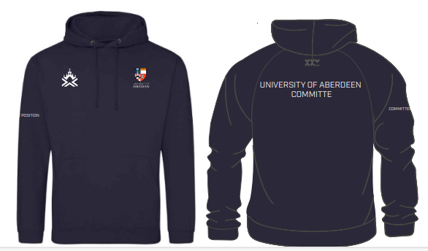 | 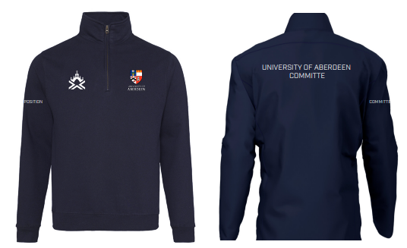 | 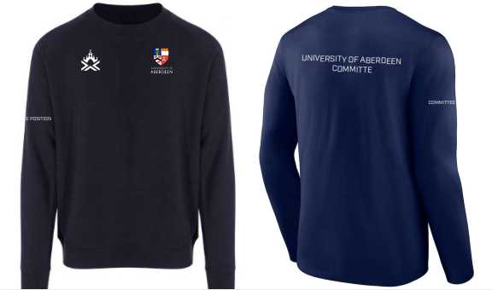 | 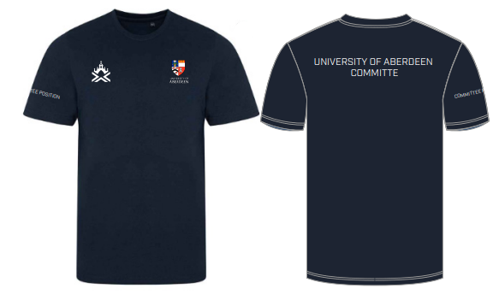

Contact Details
 | Contact Name |  |  |  | Contact Tel No.
 | Activity |  |  |  | Committee Position
 | Activity @AUSA Email address
 | Product Type  i.e., ¼ zip sweatshirt |  | Style Option  A, B, C | Name  if selected style option C |  | Committee Position  if selected style option C |  | Size  XS to 3XL | Cost
 |  |  |  |  |  |  |  |  | £0
 |  |  |  |  |  |  |  |  | £0
 |  |  |  |  |  |  |  |  | £0
 |  |  |  |  |  |  |  |  | £0
 |  |  |  |  |  |  |  |  | £0
 |  |  |  |  |  |  |  |  | £0
 |  |  |  |  |  |  |  |  | £0
 |  |  |  |  |  |  |  |  | £0
 |  |  |  |  |  |  |  |  | £0
 |  |  |  |  |  |  |  |  | £0
 |  |  |  |  |  |  |  |  | £0
 |  |  |  |  |  |  |  |  | £0
 |  |  |  |  |  |  |  |  | £0
 |  |  |  |  |  |  |  |  | £0
 |  |  |  |  |  |  |  |  | £0
 | Delivery Cost (to be included if applicable) (£6.95 for orders under £250, £0 for over £250) |  |  |  |  |  |  |  | £0
 | TOTAL TO BE PAID  To update total automatically, click on the total sum until it highlights in grey and press F9 |  |  |  |  |  |  |  | £0.00

